**Git Confliction Issues and Fix**

Student1@D-AF-05 MINGW64 ~/Documents/VS Code Main Folder/Classes/Class No.9

$ cd Admin/

Student1@D-AF-05 MINGW64 ~/Documents/VS Code Main Folder/Classes/Class No.9/Admin

$ git init

Initialized empty Git repository in C:/Users/Student1/Documents/VS Code Main Folder/Classes/Class No.9/Admin/.git/

Student1@D-AF-05 MINGW64 ~/Documents/VS Code Main Folder/Classes/Class No.9/Admin (master)

$ git remote add origin git@github.com:FasihUrRahman/ConflictErrorFix.git

Student1@D-AF-05 MINGW64 ~/Documents/VS Code Main Folder/Classes/Class No.9/Admin (master)

$ git add .

Student1@D-AF-05 MINGW64 ~/Documents/VS Code Main Folder/Classes/Class No.9/Admin (master)

$ git commit -m "Update by Admin"

[master (root-commit) e045e33] Update by Admin

1 file changed, 0 insertions(+), 0 deletions(-)

create mode 100644 index.html

Student1@D-AF-05 MINGW64 ~/Documents/VS Code Main Folder/Classes/Class No.9/Admin (master)

$ git origin master

git: 'origin' is not a git command. See 'git --help'.

Student1@D-AF-05 MINGW64 ~/Documents/VS Code Main Folder/Classes/Class No.9/Admin (master)

$ git push origin master

Enumerating objects: 3, done.

Counting objects: 100% (3/3), done.

Writing objects: 100% (3/3), 231 bytes | 231.00 KiB/s, done.

Total 3 (delta 0), reused 0 (delta 0), pack-reused 0

To github.com:FasihUrRahman/ConflictErrorFix.git

* [new branch] master -> master

Student1@D-AF-05 MINGW64 ~/Documents/VS Code Main Folder/Classes/Class No.9/Admin (master)

$ cd ..

Student1@D-AF-05 MINGW64 ~/Documents/VS Code Main Folder/Classes/Class No.9

$ cd User1

Student1@D-AF-05 MINGW64 ~/Documents/VS Code Main Folder/Classes/Class No.9/User1

$ git clone git@github.com:FasihUrRahman/ConflictErrorFix.git

Cloning into 'ConflictErrorFix'...

remote: Enumerating objects: 3, done.

remote: Counting objects: 100% (3/3), done.

remote: Total 3 (delta 0), reused 3 (delta 0), pack-reused 0

Receiving objects: 100% (3/3), done.

Student1@D-AF-05 MINGW64 ~/Documents/VS Code Main Folder/Classes/Class No.9/User1

$ cd ConflictErrorFix/

Student1@D-AF-05 MINGW64 ~/Documents/VS Code Main Folder/Classes/Class No.9/User1/ConflictErrorFix (master)

$ code index.html

Student1@D-AF-05 MINGW64 ~/Documents/VS Code Main Folder/Classes/Class No.9/User1/ConflictErrorFix (master)

$ git checkout -b User1

Switched to a new branch 'User1'

Student1@D-AF-05 MINGW64 ~/Documents/VS Code Main Folder/Classes/Class No.9/User1/ConflictErrorFix (User1)

$ git add .

Student1@D-AF-05 MINGW64 ~/Documents/VS Code Main Folder/Classes/Class No.9/User1/ConflictErrorFix (User1)

$ git commit -m "Update by User1"

[User1 a2246ca] Update by User1

1 file changed, 13 insertions(+)

Student1@D-AF-05 MINGW64 ~/Documents/VS Code Main Folder/Classes/Class No.9/User1/ConflictErrorFix (User1)

$ git push origin User1

Enumerating objects: 5, done.

Counting objects: 100% (5/5), done.

Delta compression using up to 4 threads

Compressing objects: 100% (2/2), done.

Writing objects: 100% (3/3), 465 bytes | 232.00 KiB/s, done.

Total 3 (delta 0), reused 0 (delta 0), pack-reused 0

remote:

remote: Create a pull request for 'User1' on GitHub by visiting:

remote: https://github.com/FasihUrRahman/ConflictErrorFix/pull/new/User1

remote:

To github.com:FasihUrRahman/ConflictErrorFix.git

* [new branch] User1 -> User1

Student1@D-AF-05 MINGW64 ~/Documents/VS Code Main Folder/Classes/Class No.9/User1/ConflictErrorFix (User1)

$ cd ../../Admin/

Student1@D-AF-05 MINGW64 ~/Documents/VS Code Main Folder/Classes/Class No.9/Admin (master)

$ git pull origin User1

remote: Enumerating objects: 5, done.

remote: Counting objects: 100% (5/5), done.

remote: Compressing objects: 100% (2/2), done.

remote: Total 3 (delta 0), reused 3 (delta 0), pack-reused 0

Unpacking objects: 100% (3/3), 445 bytes | 4.00 KiB/s, done.

From github.com:FasihUrRahman/ConflictErrorFix

* branch User1 -> FETCH_HEAD

* [new branch] User1 -> origin/User1

Updating e045e33..a2246ca

Fast-forward

index.html | 13 +++++++++++++

1 file changed, 13 insertions(+)

Student1@D-AF-05 MINGW64 ~/Documents/VS Code Main Folder/Classes/Class No.9/Admin (master)

$ cd ../User2

Student1@D-AF-05 MINGW64 ~/Documents/VS Code Main Folder/Classes/Class No.9/User2

$ cd ../Admin/

Student1@D-AF-05 MINGW64 ~/Documents/VS Code Main Folder/Classes/Class No.9/Admin (master)

$ git push origin master

Total 0 (delta 0), reused 0 (delta 0), pack-reused 0

To github.com:FasihUrRahman/ConflictErrorFix.git

e045e33..a2246ca master -> master

Student1@D-AF-05 MINGW64 ~/Documents/VS Code Main Folder/Classes/Class No.9/Admin (master)

$ cd ../User2

Student1@D-AF-05 MINGW64 ~/Documents/VS Code Main Folder/Classes/Class No.9/User2

$ git clone git@github.com:FasihUrRahman/ConflictErrorFix.git

Cloning into 'ConflictErrorFix'...

remote: Enumerating objects: 6, done.

remote: Counting objects: 100% (6/6), done.

remote: Compressing objects: 100% (3/3), done.

remote: Total 6 (delta 0), reused 6 (delta 0), pack-reused 0

Receiving objects: 100% (6/6), done.

Student1@D-AF-05 MINGW64 ~/Documents/VS Code Main Folder/Classes/Class No.9/User2

$ cd ConflictErrorFix/

Student1@D-AF-05 MINGW64 ~/Documents/VS Code Main Folder/Classes/Class No.9/User2/ConflictErrorFix (master)

$ code index.html

Student1@D-AF-05 MINGW64 ~/Documents/VS Code Main Folder/Classes/Class No.9/User2/ConflictErrorFix (master)

$ git add .

Student1@D-AF-05 MINGW64 ~/Documents/VS Code Main Folder/Classes/Class No.9/User2/ConflictErrorFix (master)

$ git add .

Student1@D-AF-05 MINGW64 ~/Documents/VS Code Main Folder/Classes/Class No.9/User2/ConflictErrorFix (master)

$ git checkout -b User2

Switched to a new branch 'User2'

Student1@D-AF-05 MINGW64 ~/Documents/VS Code Main Folder/Classes/Class No.9/User2/ConflictErrorFix (User2)

$ git add .

Student1@D-AF-05 MINGW64 ~/Documents/VS Code Main Folder/Classes/Class No.9/User2/ConflictErrorFix (User2)

$ git commit -m 'Update by User2'

[User2 10e3601] Update by User2

1 file changed, 1 insertion(+), 1 deletion(-)

Student1@D-AF-05 MINGW64 ~/Documents/VS Code Main Folder/Classes/Class No.9/User2/ConflictErrorFix (User2)

$ git push origin User2

Enumerating objects: 5, done.

Counting objects: 100% (5/5), done.

Delta compression using up to 4 threads

Compressing objects: 100% (2/2), done.

Writing objects: 100% (3/3), 324 bytes | 324.00 KiB/s, done.

Total 3 (delta 1), reused 0 (delta 0), pack-reused 0

remote: Resolving deltas: 100% (1/1), completed with 1 local object.

remote:

remote: Create a pull request for 'User2' on GitHub by visiting:

remote: https://github.com/FasihUrRahman/ConflictErrorFix/pull/new/User2

remote:

To github.com:FasihUrRahman/ConflictErrorFix.git

* [new branch] User2 -> User2

Student1@D-AF-05 MINGW64 ~/Documents/VS Code Main Folder/Classes/Class No.9/User2/ConflictErrorFix (User2)

$ cd ../

Student1@D-AF-05 MINGW64 ~/Documents/VS Code Main Folder/Classes/Class No.9/User2

$ cd ../User1/ConflictErrorFix/

Student1@D-AF-05 MINGW64 ~/Documents/VS Code Main Folder/Classes/Class No.9/User1/ConflictErrorFix (User1)

$ git add .

Student1@D-AF-05 MINGW64 ~/Documents/VS Code Main Folder/Classes/Class No.9/User1/ConflictErrorFix (User1)

$ git commit -m "New Update by User1"

[User1 62f7c0f] New Update by User1

1 file changed, 1 insertion(+), 1 deletion(-)

Student1@D-AF-05 MINGW64 ~/Documents/VS Code Main Folder/Classes/Class No.9/User1/ConflictErrorFix (User1)

$ git push origin User1

Enumerating objects: 5, done.

Counting objects: 100% (5/5), done.

Delta compression using up to 4 threads

Compressing objects: 100% (2/2), done.

Writing objects: 100% (3/3), 325 bytes | 325.00 KiB/s, done.

Total 3 (delta 1), reused 0 (delta 0), pack-reused 0

remote: Resolving deltas: 100% (1/1), completed with 1 local object.

To github.com:FasihUrRahman/ConflictErrorFix.git

a2246ca..62f7c0f User1 -> User1

Student1@D-AF-05 MINGW64 ~/Documents/VS Code Main Folder/Classes/Class No.9/User1/ConflictErrorFix (User1)

$ cd ../../Admin/

Student1@D-AF-05 MINGW64 ~/Documents/VS Code Main Folder/Classes/Class No.9/Admin (master)

$ git pull origin User1

remote: Enumerating objects: 5, done.

remote: Counting objects: 100% (5/5), done.

remote: Compressing objects: 100% (1/1), done.

remote: Total 3 (delta 1), reused 3 (delta 1), pack-reused 0

Unpacking objects: 100% (3/3), 305 bytes | 2.00 KiB/s, done.

From github.com:FasihUrRahman/ConflictErrorFix

* branch User1 -> FETCH_HEAD

a2246ca..62f7c0f User1 -> origin/User1

Updating a2246ca..62f7c0f

Fast-forward

index.html | 2 +-

1 file changed, 1 insertion(+), 1 deletion(-)

Student1@D-AF-05 MINGW64 ~/Documents/VS Code Main Folder/Classes/Class No.9/Admin (master)

$ git merge User1

merge: User1 - not something we can merge

Did you mean this?

origin/User1

Student1@D-AF-05 MINGW64 ~/Documents/VS Code Main Folder/Classes/Class No.9/Admin (master)

$ git pull origin User2

remote: Enumerating objects: 5, done.

remote: Counting objects: 100% (5/5), done.

remote: Compressing objects: 100% (1/1), done.

remote: Total 3 (delta 1), reused 3 (delta 1), pack-reused 0

Unpacking objects: 100% (3/3), 304 bytes | 1024 bytes/s, done.

From github.com:FasihUrRahman/ConflictErrorFix

* branch User2 -> FETCH_HEAD

* [new branch] User2 -> origin/User2

Auto-merging index.html

CONFLICT (content): Merge conflict in index.html

Automatic merge failed; fix conflicts and then commit the result.

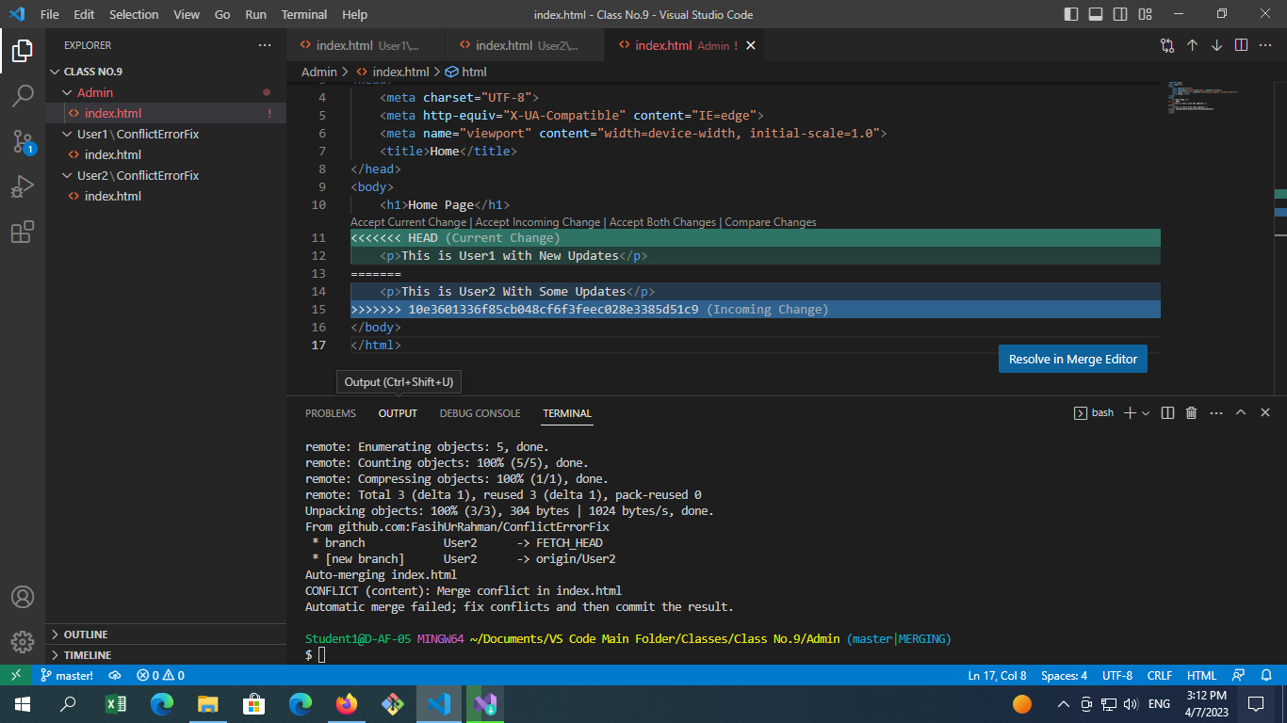

Student1@D-AF-05 MINGW64 ~/Documents/VS Code Main Folder/Classes/Class No.9/Admin (master|MERGING)

$ git commit

error: Committing is not possible because you have unmerged files.

hint: Fix them up in the work tree, and then use 'git add/rm <file>'

hint: as appropriate to mark resolution and make a commit.

fatal: Exiting because of an unresolved conflict.

U index.html

Student1@D-AF-05 MINGW64 ~/Documents/VS Code Main Folder/Classes/Class No.9/Admin (master|MERGING)

$ git add .

Student1@D-AF-05 MINGW64 ~/Documents/VS Code Main Folder/Classes/Class No.9/Admin (master|MERGING)

$ git commit

[master 1d0080c] Merge branch 'User2' of github.com:FasihUrRahman/ConflictErrorFix

Student1@D-AF-05 MINGW64 ~/Documents/VS Code Main Folder/Classes/Class No.9/Admin (master)

$ git push origin master

Enumerating objects: 1, done.

Counting objects: 100% (1/1), done.

Writing objects: 100% (1/1), 261 bytes | 261.00 KiB/s, done.

Total 1 (delta 0), reused 0 (delta 0), pack-reused 0

To github.com:FasihUrRahman/ConflictErrorFix.git

a2246ca..1d0080c master -> master